ATOC5860 – Application Lab #6
Machine Learning with Weather Data
Spring 2022

Note: You will need to use the python environment provided (environment.yml), especially for notebook #2. These notebooks were written by Eleanor Middlemas in 2020 (https://github.com/e-middlemas/ML_application_lab). They were last adapted/updated for use in ATOC5860 during Spring 2022.

Notebook #1
ATOC5860_applicationlab6_cluster_mesa_data.ipynb

LEARNING GOALS
1) Use k-means clustering as an example of unsupervised (grouping events into different categories) machine learning
2) Become familiar with the limits and applicability of K-means clustering to detect seasons in Boulder, Colorado
3) Assess sensitivity of K-means to standardization, changing the variables used for the clustering (also called “features”), and number of clusters (4 vs. 3).

DATA and UNDERLYING SCIENCE:
You will be working with weather data from the NCAR Mesa Laboratory in Boulder, Colorado. We'll call this dataset the "Mesa dataset". The data go from 2016-2021. Information on the site and the instruments is here: https://www.eol.ucar.edu/content/ncar-foothills-lab-weather-station-information. Real-time data from the site is here: https://archive.eol.ucar.edu/cgi-bin/weather.cgi?site=ml. Note: Each year in this dataset has 365 days. Leap year data (i.e., Feb. 29 data for 2016 and 2020 have been excluded.)

In this notebook, you use K-means clustering to classify the mesa dataset weather data into different clusters. Why would we cluster weather observations? We already know which observations are in which season by looking at the date. But we all know that a day in February sometimes feels like summer and a day in September can feel like winter. We often have multiple seasons in a single week... So this could be quite fun to see how the algorithm decides how to cluster our data and assign each day to a "season". :) Will each cluster will look like a season – On Va Voir (We’ll See)!

Questions to guide your analysis of Notebook #1:

- Start with 4 clusters. Cluster the data at 17 UTC (mid-day in Colorado). What is the seasonal occurrence of the 4 clusters? Do the 4 clusters correspond to Fall, Winter, Spring, and Summer? Why or why not?
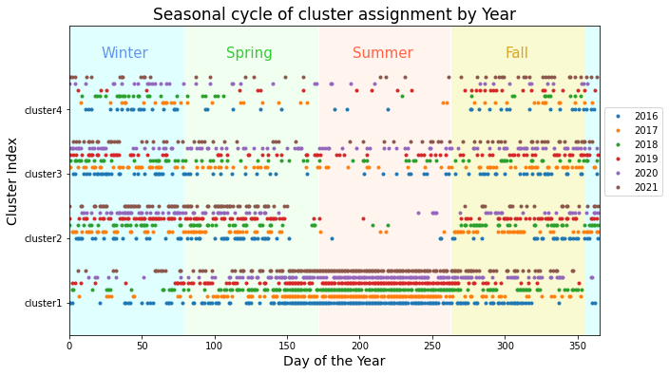
The 4 clusters don’t seem to correspond well with the four seasons. Summer seems well-represented by cluster 1, but the remaining clusters are unclear. Cluster 2 may be winter or spring, but also captures must of fall. Cluster 3 may represent fall or winter. Finally, Cluster 4 doesn’t appear to represent anything.

2) Based on 2D and 3D scatter plots of the cluster centers and the data – Which weather variables help (or NOT help) define the clusters?

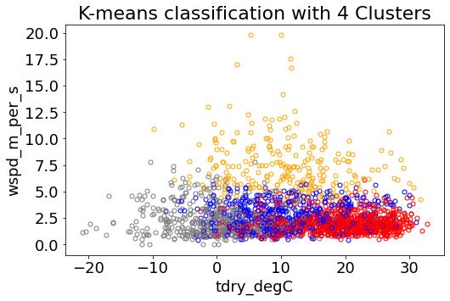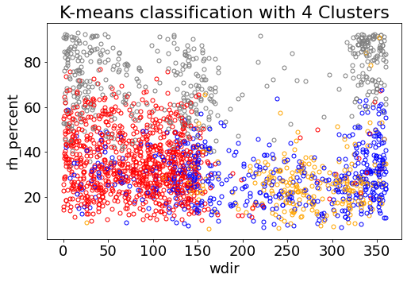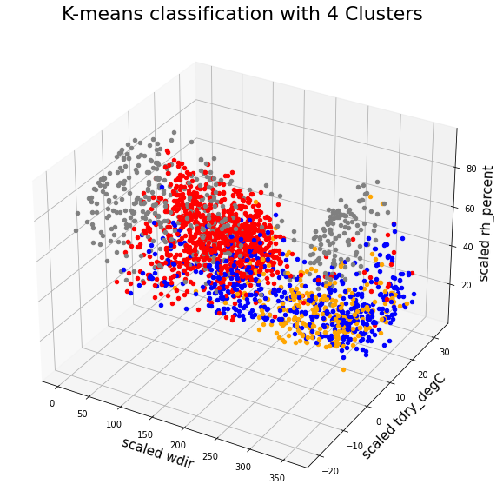
The clusters are identified by red (cluster 1), blue (cluster 2), grey (cluster 3), and orange (cluster 4). Temperature does not seem to help define the clusters. Windspeed seems to add some, but potentially not a lot. Relative humidity seems to create some pretty distinct clusters, while wind direction may potentially.

3) What do the clusters show during the time period from September 5-15, 2020 (Labor Day 2020)? Are the cluster assignments consistent with the weather experienced over that time period? Are there other date ranges that you would like to check out?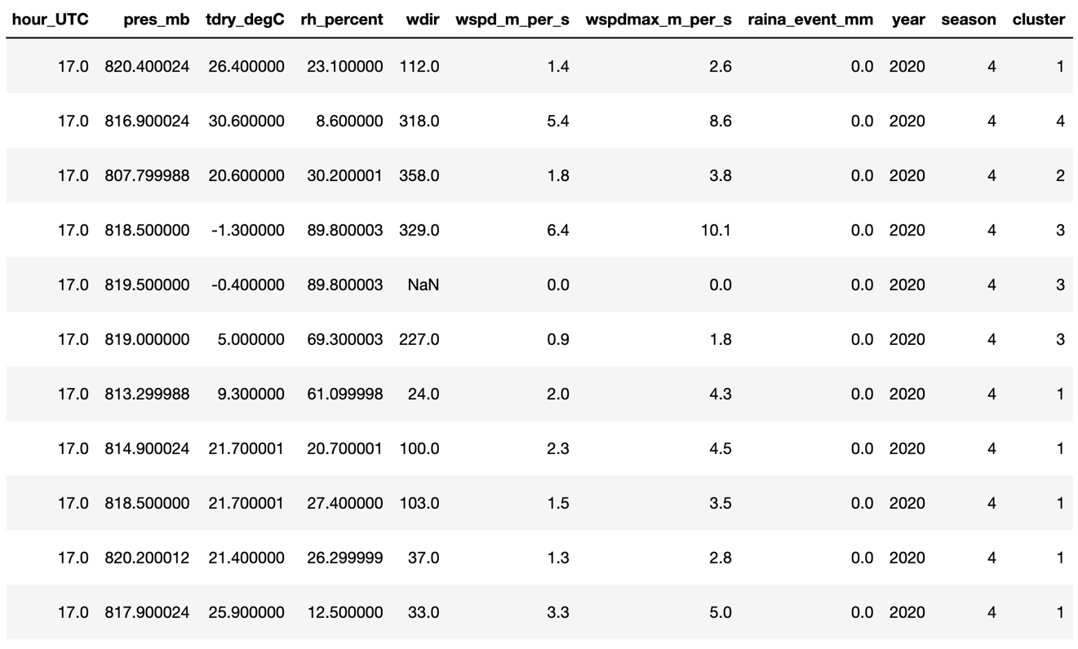
From September 5-15, the days were mainly divided between clusters 1 and 3. On Labor Day 2020, September 7, there was a huge storm. This day was categorized as in cluster 2, likely because of the low pressure. It seems like some days may be consistent with the weather. However, this may be because the days are in fall and there didn’t seem to be a defining fall cluster. If the values were pulled from summer, there may be more consistent clustering. Selecting July 10-15, all but one day were in the summer cluster.

4) Re-run the analysis. But now use three clusters instead of four clusters. Compare your cluster analyses for 4 clusters and 3 clusters. Do the results for 4 clusters or 3 clusters make more sense to you based on your analysis and also your experience living in Boulder, Colorado? Which number of clusters provides a better fit to the data?
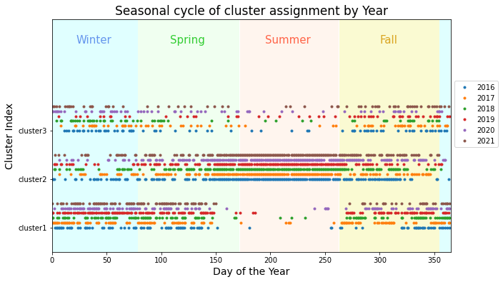
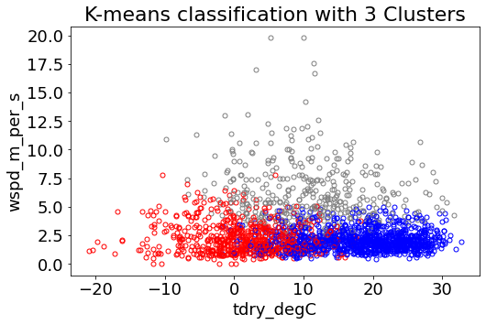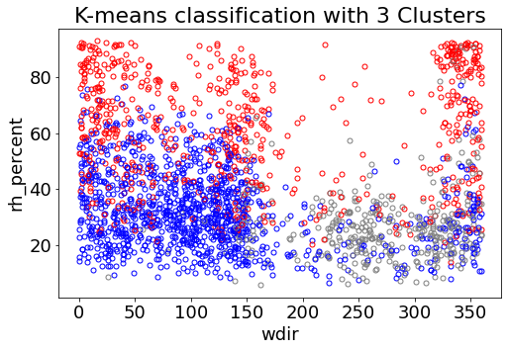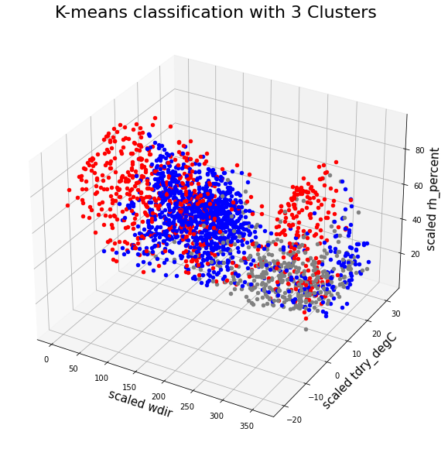
With 3 clusters, there seems to be one summer cluster, one winter cluster, one other cluster. Perhaps Cluster 3 represents the days with drastic temperature swings.

Notebook #2
OPTION #1: ATOC5860_applicationlab6_supervised_ML.ipynb – Use environment.yml
or
OPTION #2: supervised.ipynb – Run in Google CoLabs
Note: You will need to change the google drive paths to match those on your computer.

LEARNING GOALS:
- See an example of the data processing pipeline (workflow) required to utilize supervised machine learning techniques.
- Implement and compare four different supervised learning algorithms
- Understanding two outcomes of supervised learning algorithms: prediction and feature importance.
- Start building a foundation for future machine learning including the following terms: cross-validation, training vs. testing data, metrics (accuracy, recall, precision, f1 score, etc.), overfitting/underfitting, balancing datasets, hyperparameters, & feature importance. Some future learning resources are provided… but there’s a lot available! Share resources you find valuable.

DATA and UNDERLYING SCIENCE:

We will use the Christman dataset which contains weather observations from Fort Collins, Colorado for the year 2016. We will build and train four machine learning models to predict something we already know from the dataset: Is it raining?. The point is not to conduct cutting-edge research or make novel predictions. Instead, the purpose here is to showcase supervised machine learning (ML) models and methods. By the end, we hope you can walk away with more confidence to learn and apply these tools to new problems.

Let's say you want to determine which features or atmospheric variables are the best predictors of rainfall. Often, one simply regresses some metric of precipitation onto various atmospheric variables. Then, you assume that whatever returns the highest regression coefficient is the best predictor. While this approach with linear regression presents a fine first guess, it poses a few problems. Linear regression assumes: 1) atmospheric variables are linearly related to precipitation, 2) atmospheric variables are uncorrelated. Yet, both are false assumptions. While a linear relationship between predictor & predictand is a good first guess, why limit yourself to linearity when you can just as easily relax that assumption using supervised Machine Learning...

This notebook will step through the following Machine Learning model pipeline:
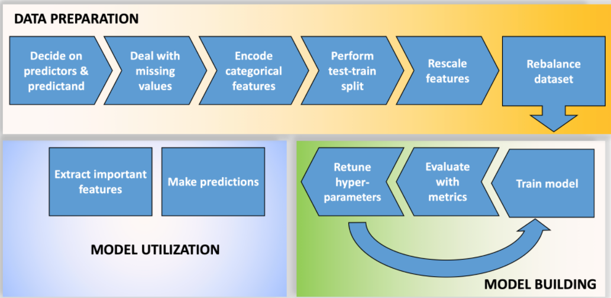

After prepping the data, we will build and train four machine learning models and make predictions with them. The four machine learning models we will implement are: Logistic regression, Random Forest, Singular vector machines/classifier, Neural Network. Finally, we will determine which variable ("feature") is the best predictor, i.e., we will assess "feature importance".

Pros/Cons of these Methods (from Eleanor Middlemas)
- Logistic regression tends to overgeneralize or underfit data, but is easy to implement, to understand and easy to back out feature importance.
- Singular Vector Machines are great at capturing complex relationships, but cannot back out feature importance. Plus, the use of the kernel makes them hard to interpret.
- Random forests are easier to understand, generally do not overfit, and can capture complex relationships, and can provide feature importance, but they can be slow to train and there are a lot of hyperparameters to choose from.
- Neural Networks are great at capturing complex relationships. But they are slow to train and are susceptible to overfitting.

Questions to guide your analysis of Notebook #2 – See also questions at the end of supervised.ipynb:

- Which machine learning model performs the best to predict rainfall? What metrics did you use to make this assessment?
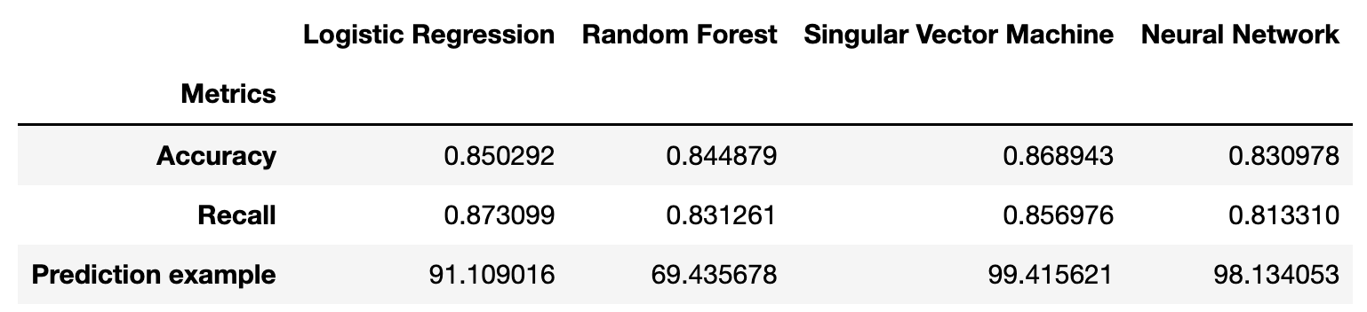

Answer: Accuracy and recall went into the metrics used to assess model performance. According to accuracy, the singular vector machine does the best to predict rainfall. Recall doesn’t care about false positives, so rainfall isn’t severe enough to care about recall. However, for accuracy, logistic regression, singular vector machine, and the neural network all do similarly. However, the random forest doesn’t do well in terms of accuracy.

2) Describe the difference between accuracy and recall. Why did we choose to use accuracy, recall, and predicted precipitation probability as a way to compare models? In forecasting: when is a false positive (you said it would rain, it didn’t rain) preferred over a false negative (you said it wouldn’t rain, it did rain)?
Answer: Recall is the ability of a model to predict how many true positives were identified correctly $\left(\frac{TP}{TP+FN}\right)$. Another way to think of this is that recall is the ability to avoid false negatives. In some extreme circumstances, recall needs to be near perfect because the cost of getting it wrong is too high. In forecasting, sometimes “you said it’d rain, but it didn’t” is preferred over “you said it wouldn’t rain, but it did.” For example, heavy rain sometimes causes rapid land shifts. Following an earthquake, emergency response teams, and the public, would likely want to know what roads to avoid when responding to calls. The cost of getting caught in a landslide with already limited resources is too high.

3) One important "gotcha" in a machine learning workflow or pipeline is the order of data preparation. Why should one should perform the train-test split before feature scaling and rebalancing? Hint: think about using a trained model for future predictions. Do you want your scaling of the testing data to depend on the training data? Why perform a test-train split at all?
Answer: If we perform the train-test split before feature scaling and rebalancing, we carry information from the train to test split and bias the model. Because we want an unbiased model, we need to perform test-train split.

4) Collinearity, or non-zero correlation among features, results in a model that is overly complex, reduces the statistical significance of the fit of the model, and prevents one from correctly identifying the importance of features. Are there features included in our machine learning models to predict rain in the Christman dataset that are collinear? If so, how do you think we should address this collinearity? A couple of suggestions: If we don’t have that many features, we could use our meteorological expertise to simply remove one of the features that shares collinearity with other features. Another way to address collinearity is to use feature regularization, or add weights that penalize features that add noise, ultimately reducing model complexity.
Answer: Some of the variables included depend on or vary with one another, so some variables may not add any new information. In our model, for example, we have relative humidity and temperature both included as input. However, relative humidity can be calculated with temperature, so temperature is “already in” relative humidity and therefore adds no new information. Another few may be windgust, wind_mph, windgust_dir, and wind_dir. In the models, windgust repeatedly appears high in importance, while the other three rank much lower. In contrast to the to the previous example, the choice of variable here is less clear; windgust wasn’t the obvious variable to keep. Therefore, a more complex method may be preferred that penalize features that add noise.

